**Task – 12**

1. Employee class with two different packages.

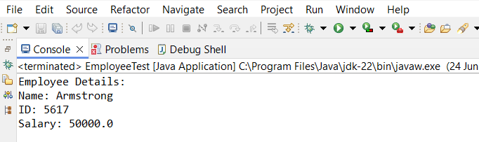

1. Create array list and delete all the strings.

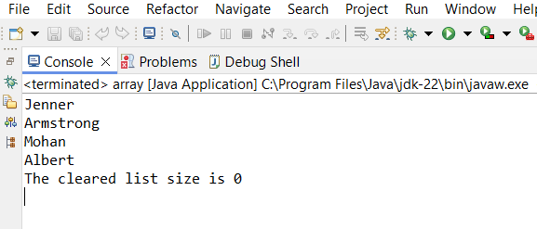

1. Create employee id and name. Arrange in ascending order.

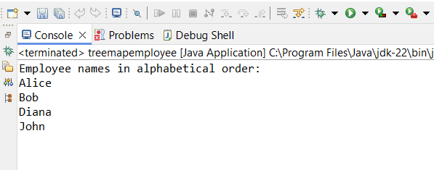

1. List to Array.

